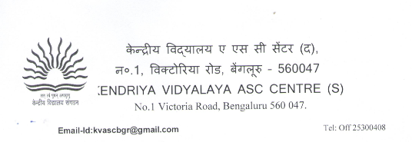

NO VACANCY FOR FRESH ADMISSION IN CLASS II AND ABOVE

